
Course Submission Cover Sheet

Module: CU6051ES Artificial Intelligence

Assignment no: 001

Weighting: 50% of the module mark

Deadline: TBC
Module Leader: Mr. Vikum Student ID:E209957

Please note that there are specific regulations concerning the use of AI and Academic Misconduct. Below are extracts from these regulations. By signing, you acknowledge that you have read and understood these extracts.

(signature:) e209957@esoft.academy Date:

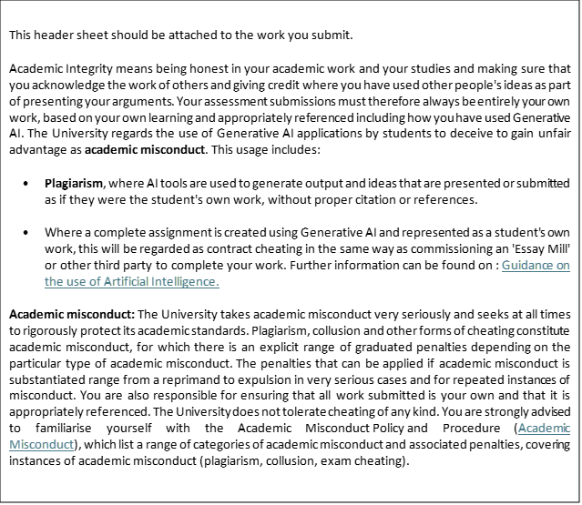

Assignment 1 (25%):
“Presentation of Research” 25% - This is a synthesis of your knowledge in the field of AI. Please submit your weekly mind maps/diagrams with 1 major synthesis of the topics covered.
This must be attempted individually.
Submission to include:
  - One document to include 10 pages of “mind-map” drawings, include labels, explanations, links as required (10 weeks, 10 diagrams)
  - All submissions will be graded using the following criteria:
- Presentation of Research 20%
- Depth of knowledge [LO1] 30%
- Synthesis of information [LO1] [LO3] 30%
- Presentation (clarity) [LO3] 20%

To receive
A : all keywords and connections clearly expressed + more depth in some areas that interest you + synthesis that shows links between topics
B: all keywords and connections clearly expressed + synthesis that shows links between some topics
C: keywords and connections clearly expressed but not complete + attempt at synthesis of topics
D: keywords and connections attempted
E: key words with limited connections
To receive
A: Excellence in all aspects
B: Good working application with clear documentation showing references
C: Working prototype with documentation showing references
D: Basic working prototype with documentation showing references
E: Attempt at prototype with documentation showing references

Marking Scheme for Assignment 1 (25%)
PRESENTATION OF RESEARCH (10%) | All 10 mind maps present, each covers 1 lesson | 10
DEPTH OF KNOWLEDGE (50%) | Each mind map explores the topic/lesson to a sufficient depth, decomposes the main topic to sub topics with clear textual annotations | 20
 | Suitable images and diagrams are given | 20
 | Relevant and valid hyperlinks (at least 3 per diagram) | 10
SYNTHESIS (30%) | Components (text, images, labels, hyperlinks etc.) are connected in a meaningful way to provide an effective overview of the topic | 30
CLARITY (10%) | Provides a clear overview of an AI topic at a glance | 10

Mind maps

Artificial intelligence

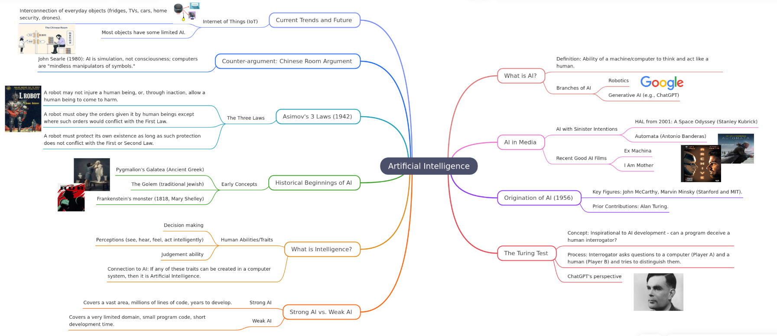

Agents

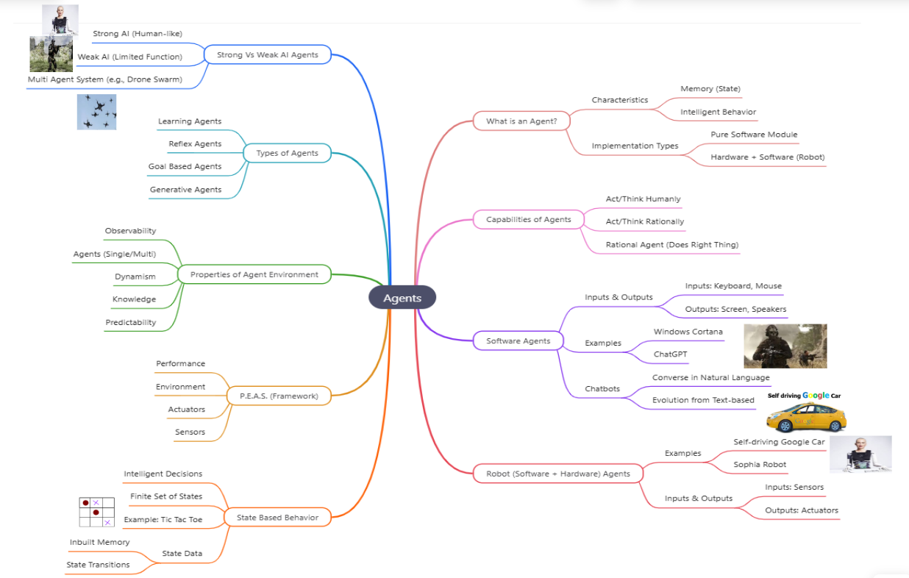

Searching

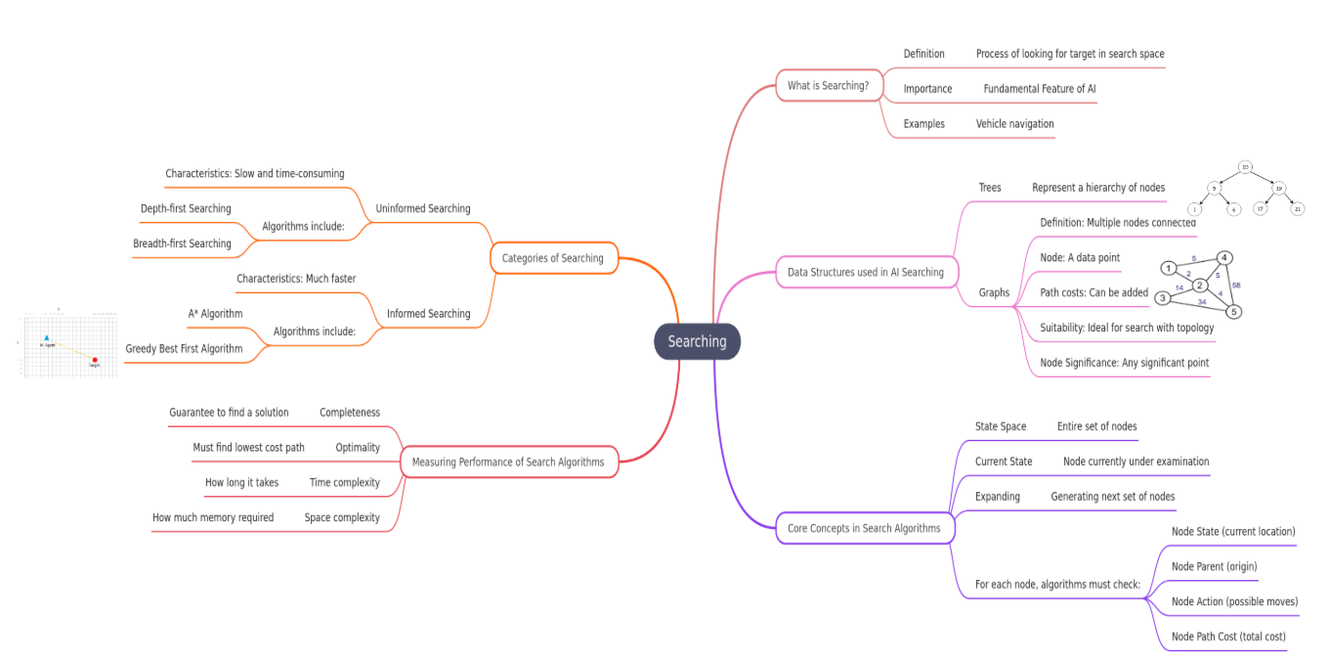

Probability

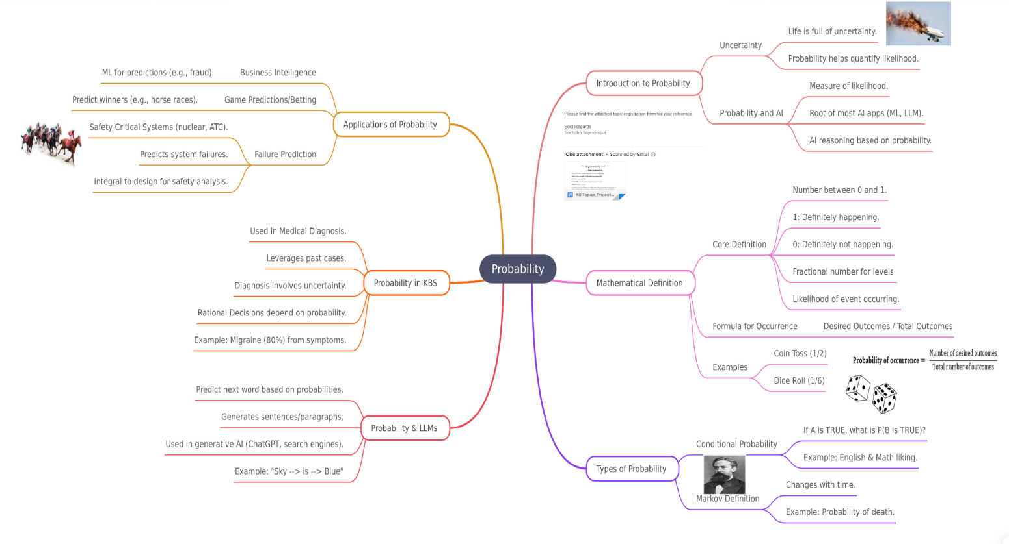

Machine Learning

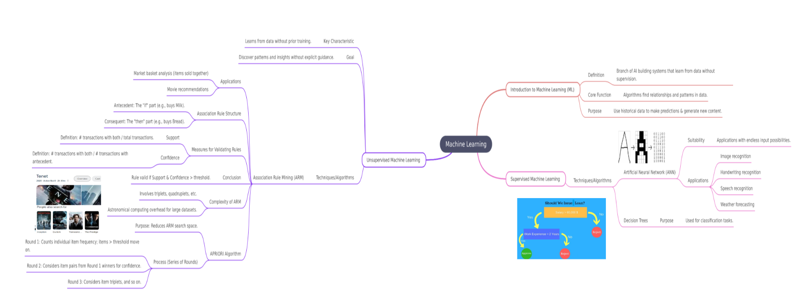

Emotional Intelligence

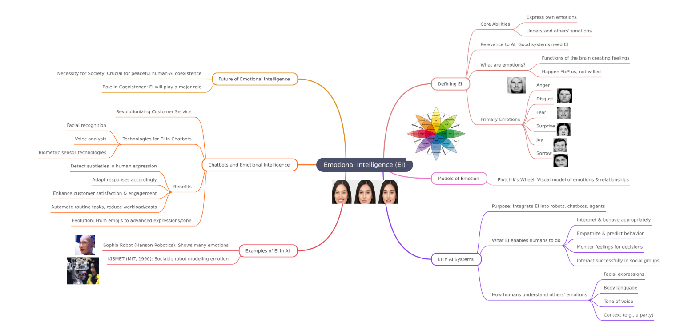

Robotics

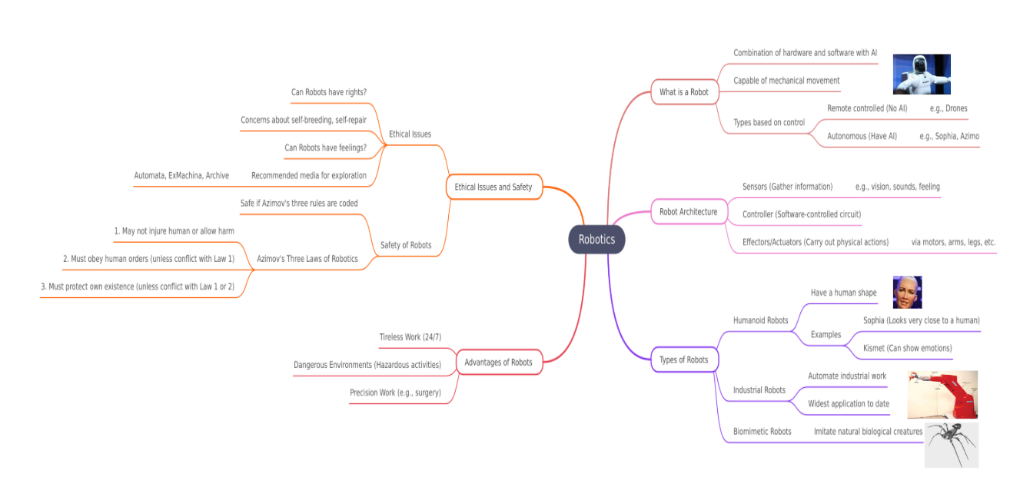

Natural Language Processes

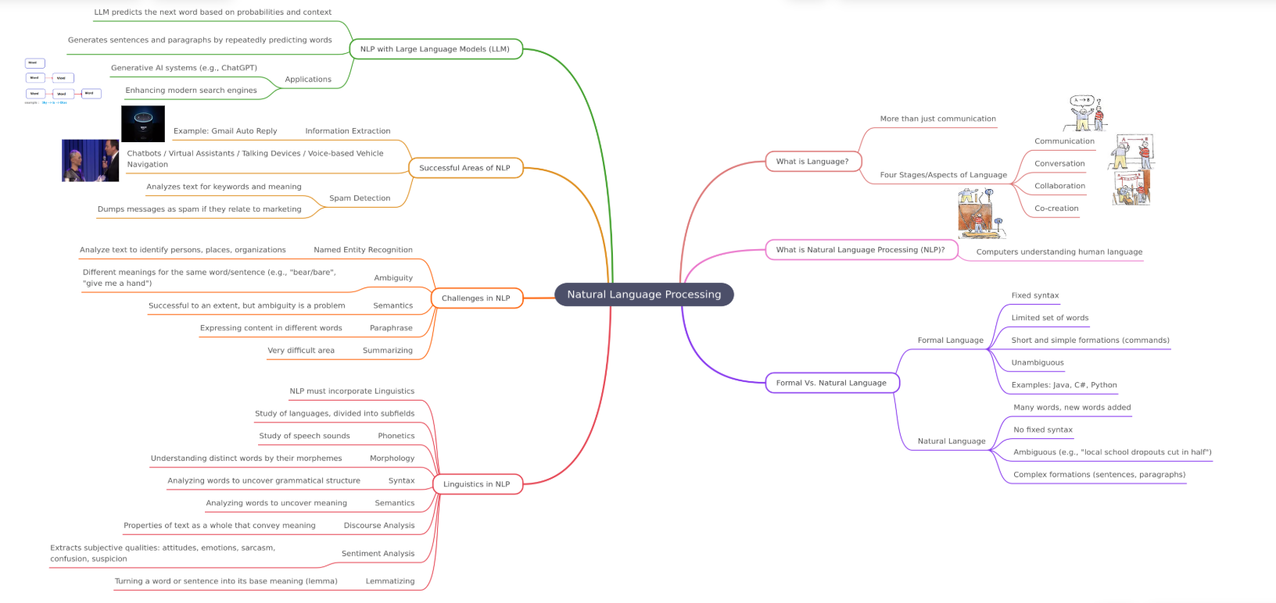

Fuzzy logic

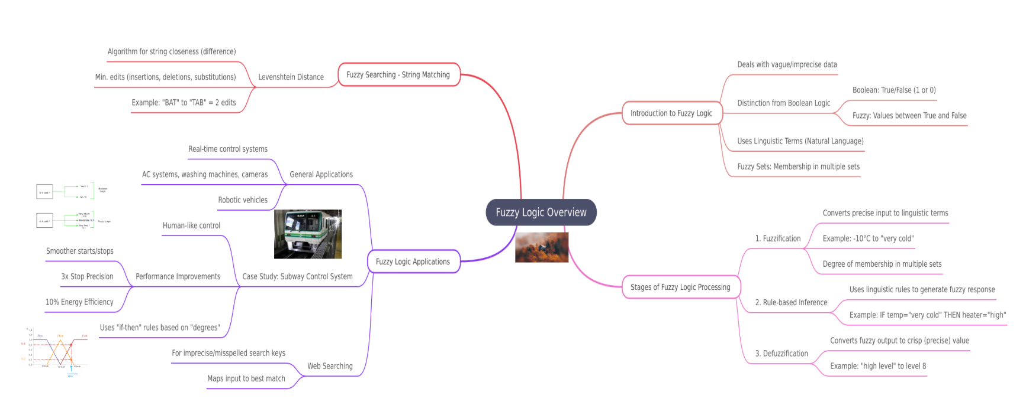

Human Augmentation

